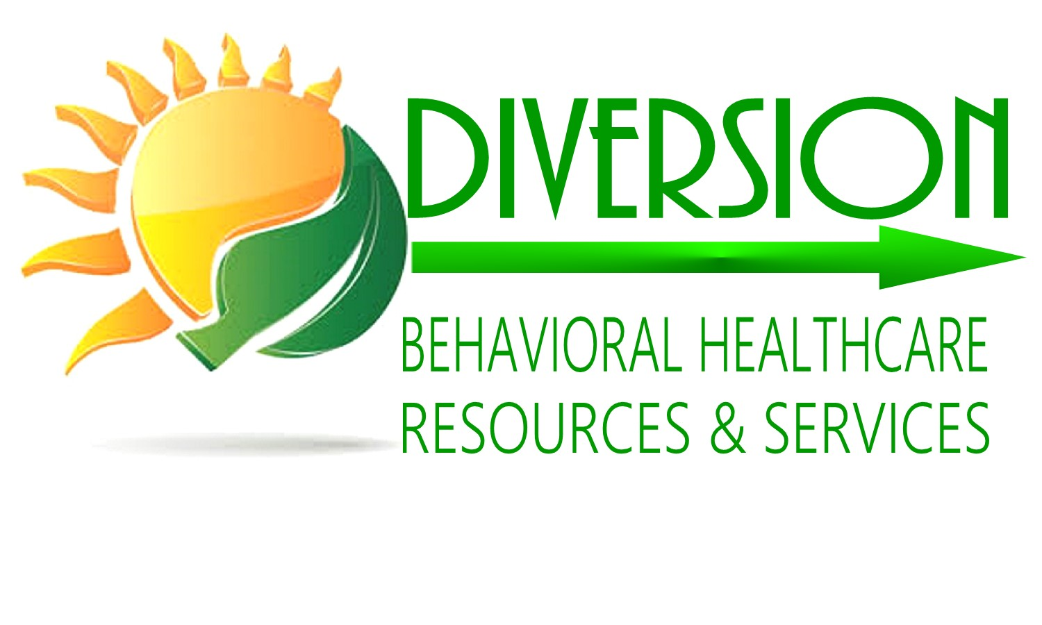



THE NATIONAL L.E.A.D. INSTITUTE
REGISTRATION FORM
Each attendee must complete a separate registration, but multiple registrations can be paid in a single payment.
Dr. Mr. Mrs. Ms. Name:_____________________________________________________________
Full Name (First, Middle, Last)

Title/Position: ____________________________________________________________________________
Institution/Organization_____________________________________________________________________ Tel: Office: ____________________________________ Mobile: ____________________________________ Email: ___________________________________________________________________________________
Training Type/Name:_______________________________________________________________________ Training Start Date: ________________________________________________________________________
REGISTRATION FEE: _______ FREE REGISTRATION: ______
PAYMENT METHOD: CASH ____ CHECK ____ CREDIT CARD: ____
Name as it appears on Credit Card ____________________________________________________________ Credit Card No. ___________________________________________________________________________ Exp. Date _______/_______ CID ___________ Signature: _________________________________________
Make check payable to: The National L.E.A.D. Institute
Refund Policy Post Registration:
15 days – 80%
21 days - 50%
Optional: Full credit towards upcoming training 7 days prior – 20%

The National L.E.A.D. Institute
Tel: (242) 677-3667 / (242) 525-3749 (BAH) (919) 714-0500 (US) Email: thenationalleadinstitute@gmail.com www.thenationalleadinstitute.org

